**PROJECT TOPIC: BLOOD BANK MANAGEMENT SYSTEM WEBSITE**

**Project Group Members:** Kushagra Dixit (Sec- F, Roll No- 27. / University Roll No.-181500344)

**Project Supervisor:** Mr. Akash Kumar Choudhary (Assistant Professor)

**About the Project:**

The "Blood Bank Management System" has been developed to override the problems

prevailing in the practicing manual system. This software is supported to eliminate and, in some cases, reduce the hardships faced by this existing system. Moreover this

system is designed for the particular need of the company to carry out operations in a

smooth and effective manner.

No formal knowledge is needed for the user to use this system. Thus, by this all proves it is user-friendly. Blood Bank Management System, as described above, can lead to error free, secure, reliable and fast management system.

**Objective of the Project:**

The main objective of the Project Blood Bank Management System is to

manage the details of Blood Bank, Blood Group, Donor, Blood Stock. It

manages all the information about Blood Bank, Record, Blood Cell, Blood Bank.

This application is to automate the complete operations of the blood bank. They need maintain hundreds of thousands of records. Also searching should be very faster so they can find required details

instantly

**Project Planning:**

Project Planning is shown with the help of Gantt Chart. Below is the chart to Analysis the work of the Website.

**Feasibility Study:**

After doing the project Blood Bank Management System, study and analysing all

the existing or required functionalities of the system, the next task is to do the feasibility study for the project. All projects are feasible - given unlimited resources and infinite time.

Feasibility study includes consideration of all the possible ways to provide a solution to the given problem. The proposed solution should satisfy all the user requirements and should be flexible enough so that future changes can be easily done based on the

future upcoming requirements.

**Methodology:**

Model View Controller or MVC as it is popularly called, is a software design pattern for developing web applications. A Model View Controller pattern is made up of the

following three parts:

• Model:

The lowest level of the pattern which is responsible for maintaining data.

• View:

This is responsible for displaying all or a portion of the data to the user.

• Controller:

Software Code that controls the interactions between the Model and View.

MVC is popular as it isolates the application logic from the user interface layer and

supports separation of concerns. The Controller receives all requests for the

application and then works with the model to prepare any data needed by the View. The View then uses the data prepared by the Controller to generate a final presentable

response.

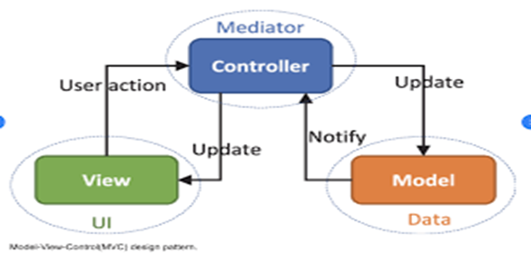

**Tools required:**

* **Hardware Requirements:** Processor- i3, Hard disk- 5GB, Memory- 1GB RAM.
* **Software Requirements:** phpMyAdmin(version-5.3.1), MySQL, fronted web.
* **Technologies Used:** Xampp, Wamp server, HTML, CSS, Oracle 8.

**Motivation:**

In a nutshell, it can be summarized that the future scope of the project circles around maintaining information regarding:

1.We will host the platform on online servers to make it accessible worldwide.

2.Integrate multiple load balancers to distribute the loads of the system.

3.Create the master and slave database structure to reduce the overload of the

database queries.

Transfusion of blood every year saves Millions of lives all over the world every year, there are Millions of Blood Donors all over the world but still there are number of countries who don’t have adequate number of blood suppliers and face the challenge of blood supply to the patients.

So, keeping this thing in mind we created this website to help the people around in a positive way and get a chance to donate our knowledge to the needy.

**Conclusion of the Project:**

Our project is only a humble venture to satisfy the needs to manage their project

work. Several user-friendly coding has also adopted. This package shall prove to be a

powerful package in satisfying all the requirements of the school. The objective of

software planning is to provide a frame work that enables the manger to make

reasonable estimates made within a limited time frame at the beginning of the software project and should be updated regularly as the project progresses.

We have left all the options open so that if there is any other future requirement

in the system by the user for the enhancement of the system then it is possible to

implement them. In the last we would like to thanks all the persons involved in the

development of the system directly or indirectly. We hope that the project will serve its purpose for which it is develop there by underlining success of process.

**References and Bibliography:**

1. **Google Search Engine**
2. **W3 Schools**
3. **Wikipedia**
4. **Google Images**
5. **Some Tutorials point**
6. **Javatpoint**

**Signature of Project Supervisor: _____________________**

**(Mr. Akash Kumar Choudhary)**